St Margaret Mary’s Cross Country Course

Course Route
Start
Finish
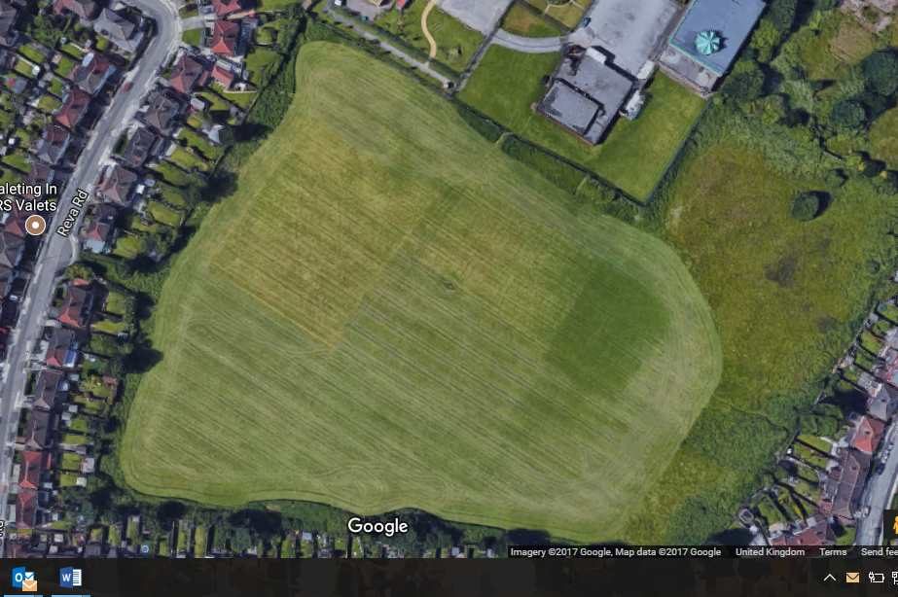
Athletes run two laps of the course

