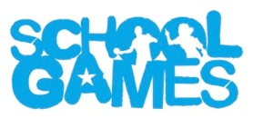
SANTA DASH 2023
School Games National Santa Dash is back for 2023
& it is going to be bigger than ever!
Congratulations on taking part in the School Games National Santa Dash organised by your local School Games Organiser! You will be joining thousands of other young people across the Country who will all be taking part on Friday 8th December. Times have been suggested so that Year Groups across the Country will be running simultaneously. If these times don’t work for your school, please feel free to take part at any time during the day. It would be great to get our Teachers, TAs, Head Teachers, Office staff, Lunchtime staff involved too!
The only request we make is that you have FUN!

YEAR GROUP | TIME
Year 4 | 9.30am
YEAR 3 | 10am
YEAR 2 | 10.30am
YEAR 1 | 11.15am
RECEPTION | 11.45am
YEAR 6 | 1.30pm
YEAR 5 | 2pm

If you are taking part, please Tweet and share some photos using:
#santasmiles #SGSantaDash
Tag your School Games Organiser and @YourSchoolGames

